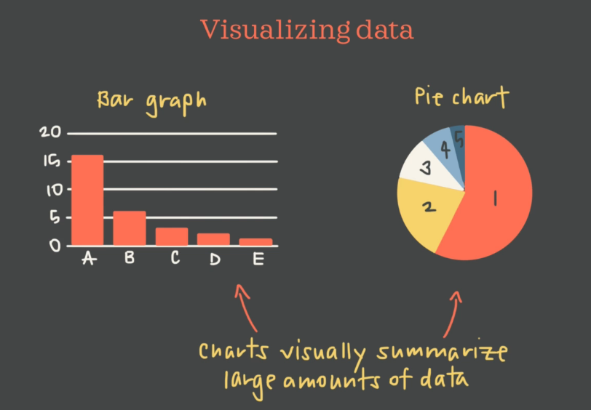

Individuals or attributes

Variables or Facts (Variables can also contains categorical variable and quantitative/numbers).

**One way data handles, single individuals. Ie within one question we can get the answers.**

We can swap if the individuals is less than the variables, refer 3rd Table.

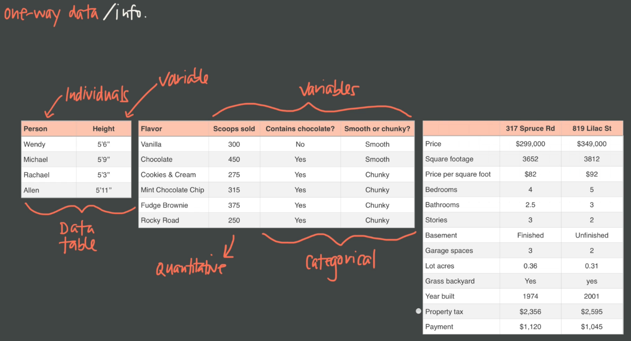

Too visualize one way data, we use 🡪 BAR GRAPH & PIE CHARTS, Line & ogives (Running Total in line graph)

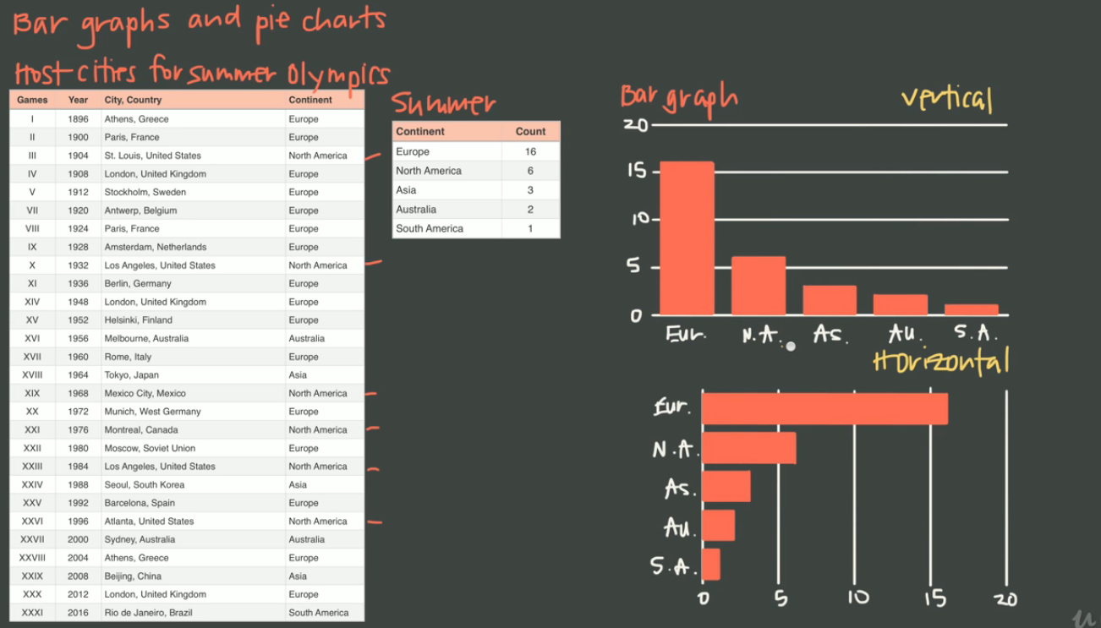

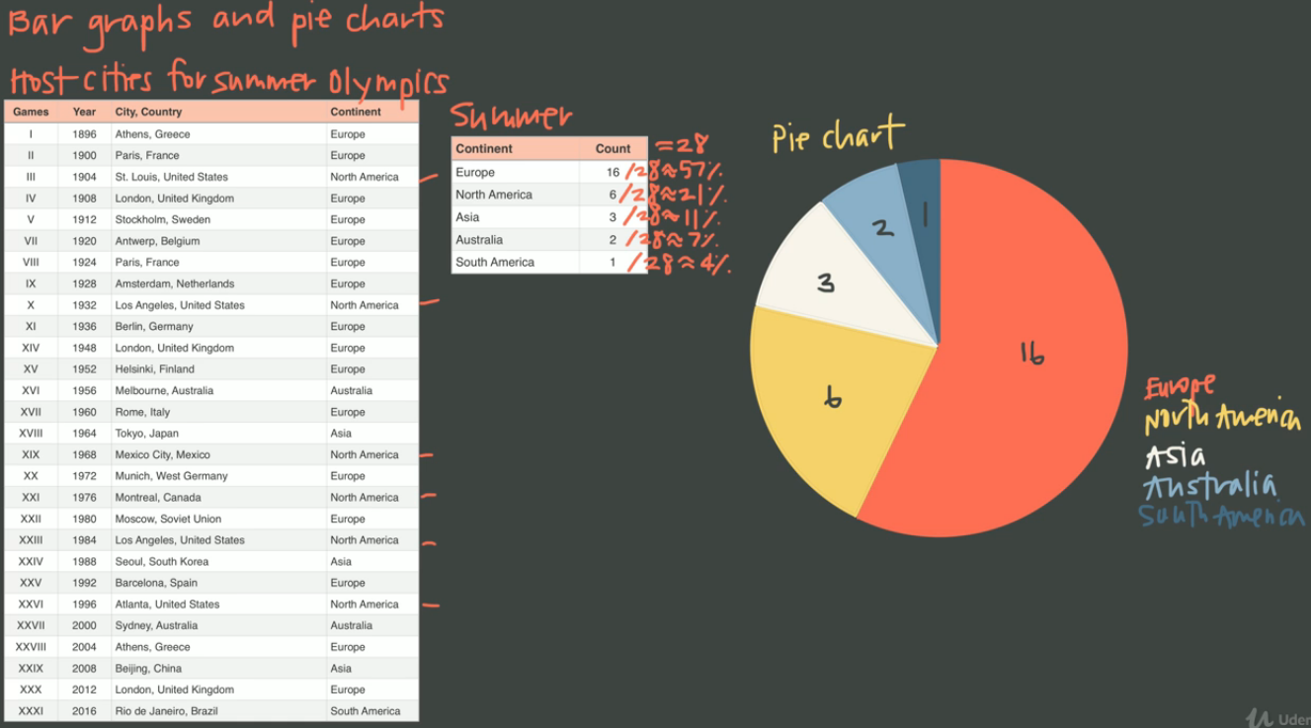

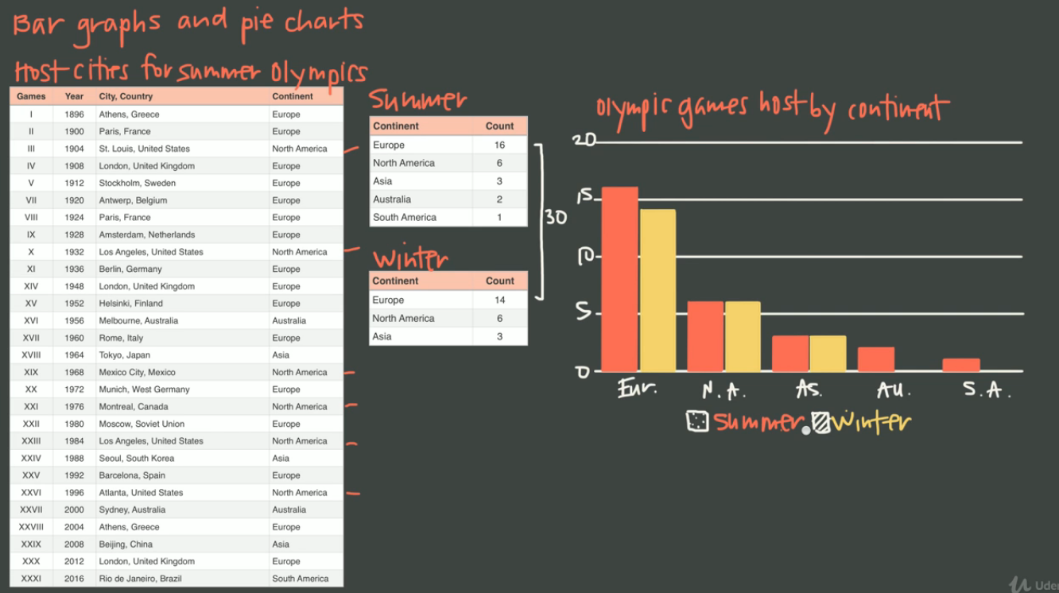

LEGENDS and title are important, that even naïve person can understand the charts without the table

A bar graph is similar to the line graph too.

When you move through time, accumulated total or there is a connection between the data points, line graph is a good choice. Because, we can get more information. If it is a category then keep with bar graph. See the below 2 examples.

Ogives🡪 running total in line graph. See the 3rd example. We can’t use ogives in temperature.

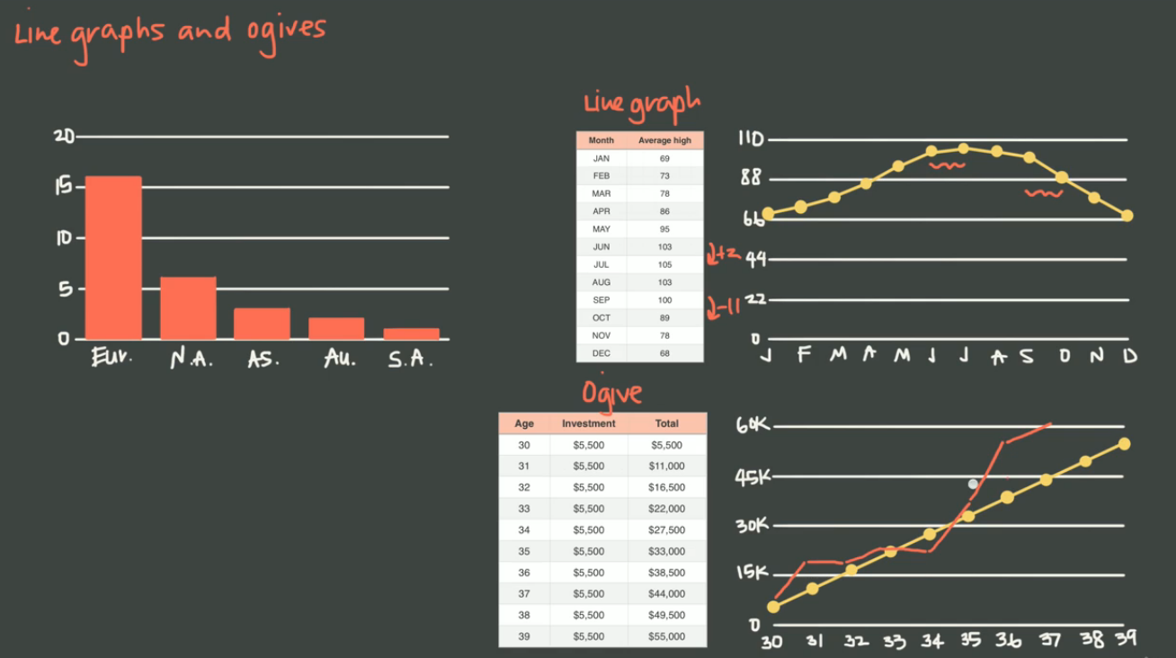

**TWO-WAY DATA:**

What is the revenue I make? Which month and which year.

Two way data is more informational, solves many questions and provides detailed drill down.

We can take sum of each year and month wise provides more insight.

Two way data is more powerful.

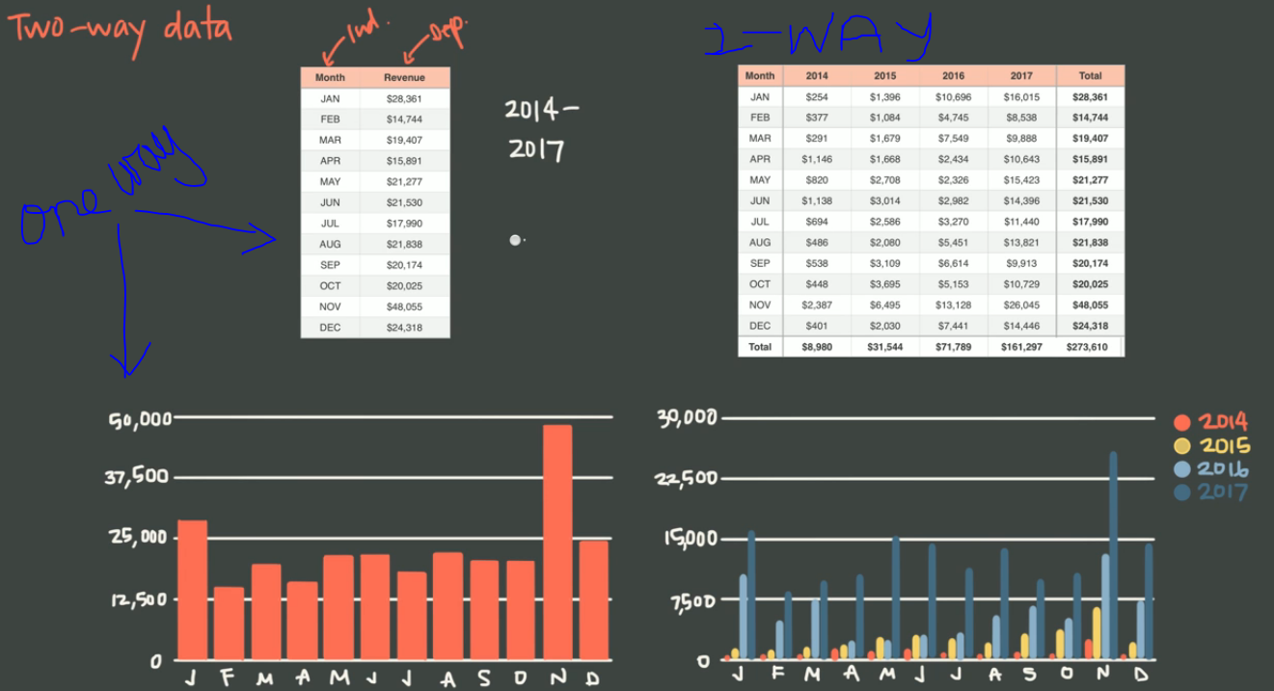

Venn diagram (To represent, two way data):

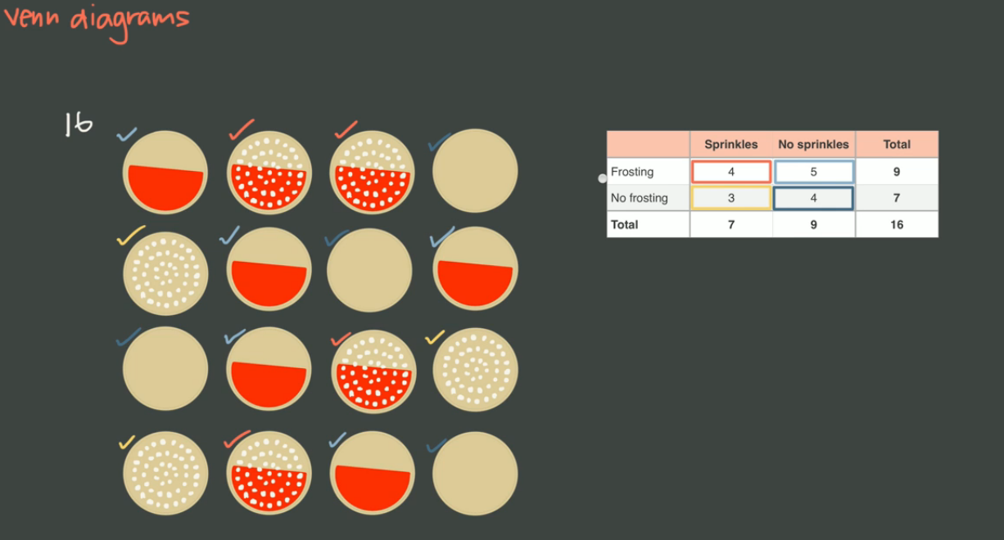

How to convert a two way table to Venn diagram

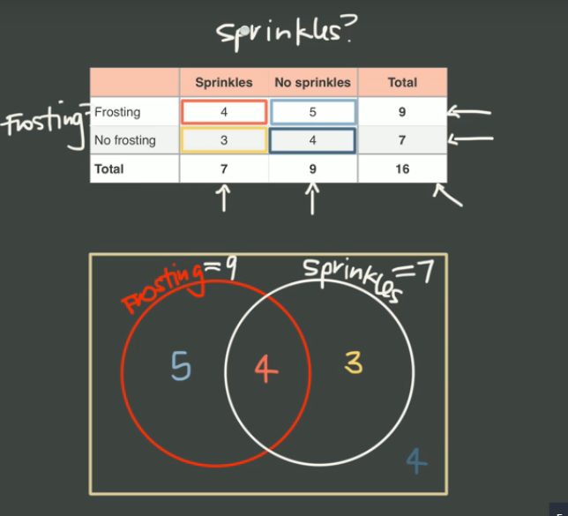

If we are comparing 2 category, then we can build two way table with Venn diagram.

**Relative Frequency Table (can be made from one way or two way):**

Can be made with column or row.

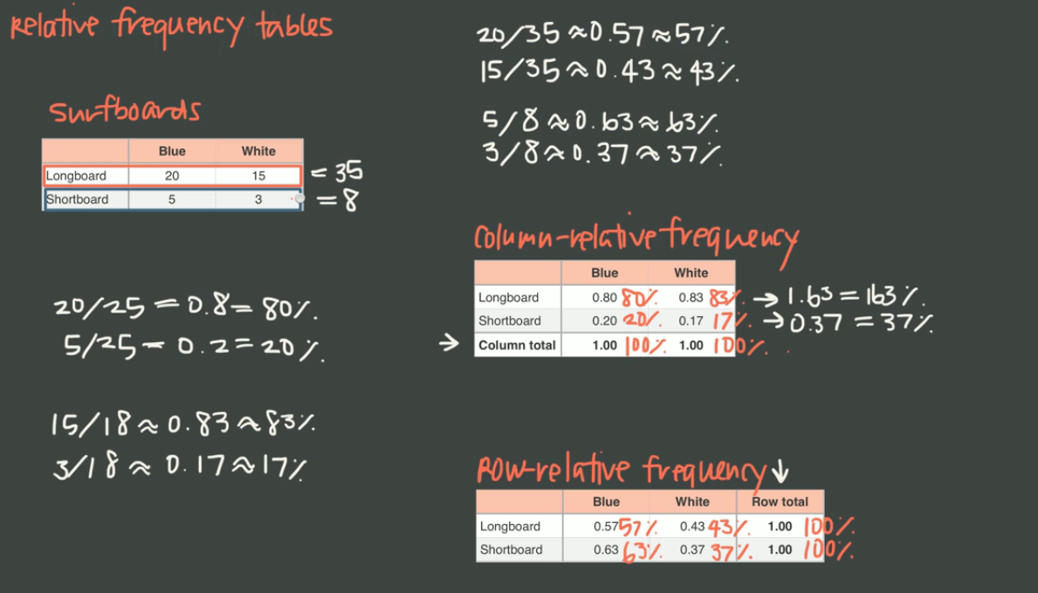

**Joint Distribution:**

The joint distribution or the joint probability distribution is the probability that a pair of events can happen.

It is combination of row and column Relative Frequency Table.

It is a much more valuable data and we can get the correlation and can answer more questions.

**Marginal Distribution**🡪 it is on the edge rows and columns (Total percentage in rows and columns)

**Conditional Distribution🡪** It depends on particular condition inside the body of the table. Conditional distribution is calculated based on the total of the row or column.

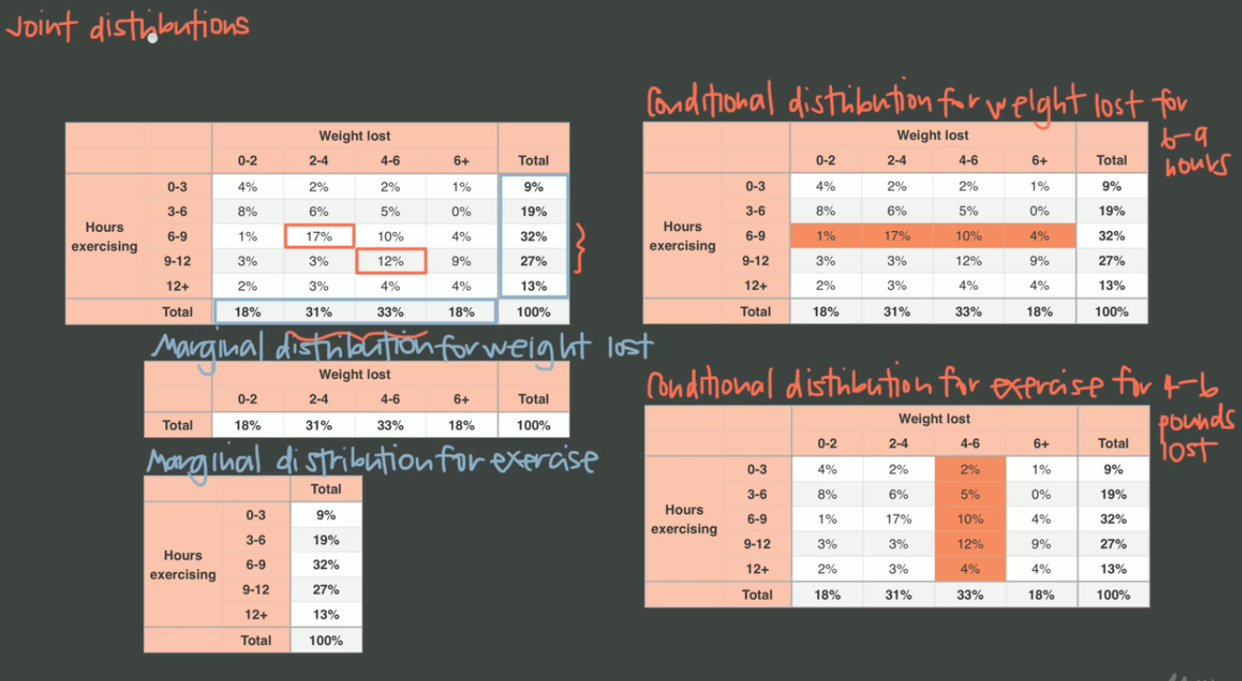

**Frequency Tables and Dot Plots:**

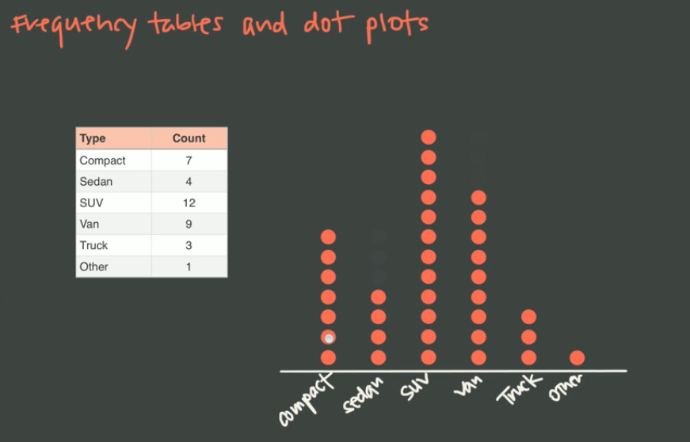

**Histogram is a great substitute for bar graph, when there is so many data (bars).**

**Histogram🡪 bucketing**

**Stem and leaf plot🡪 Stem+ Leaf (Leaf should be single digit)**

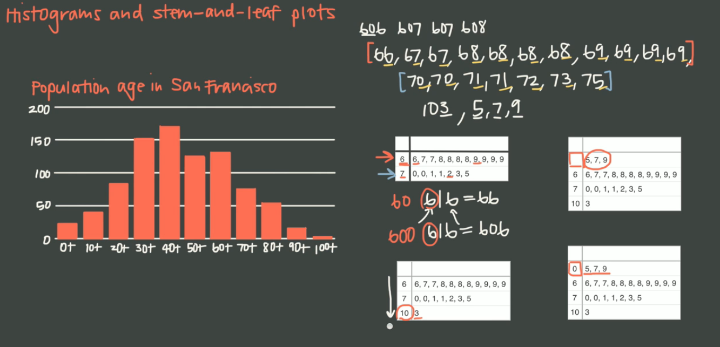

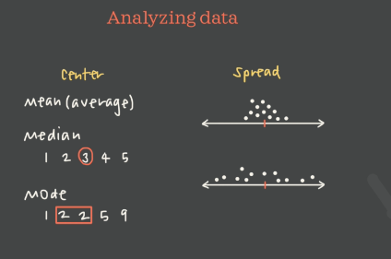

**Mean🡪 Average**

**Median🡪 Sorted middle element, if even, then take mean for 2 elements**

**Mode🡪 most occurrence**

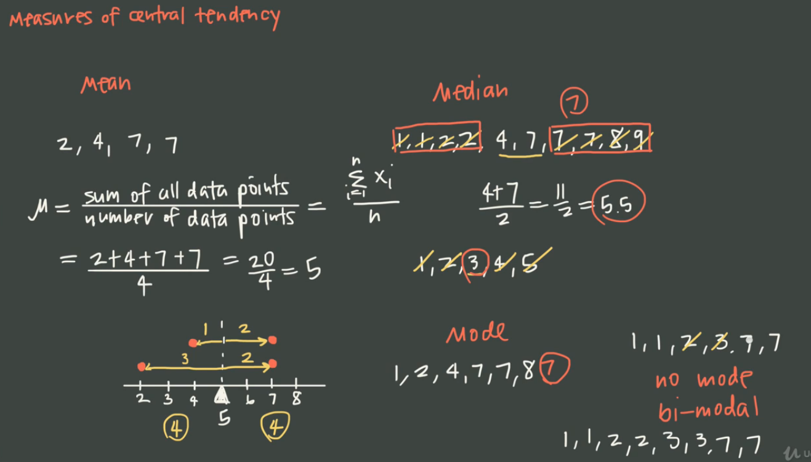

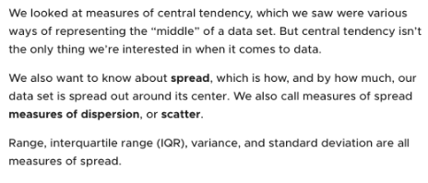

**71-68🡪 3 (Gives us the spread from the median)**

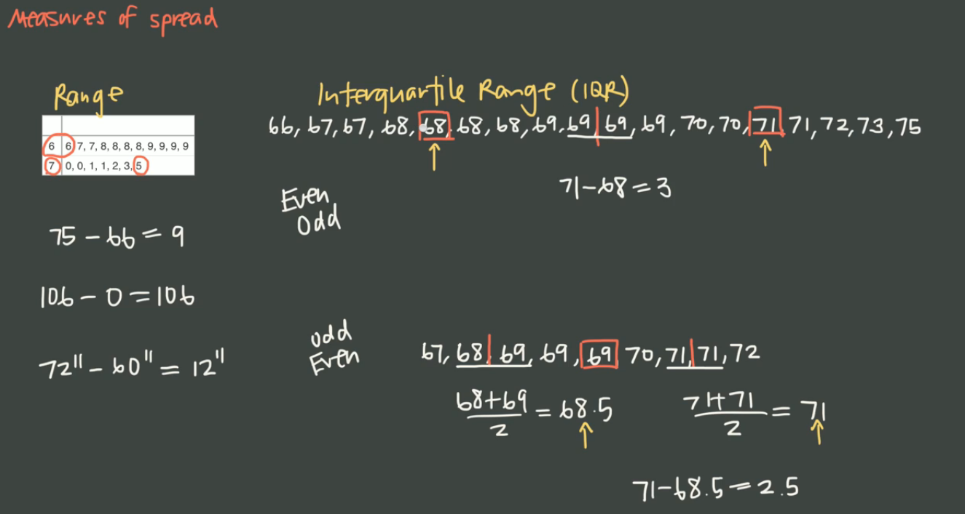

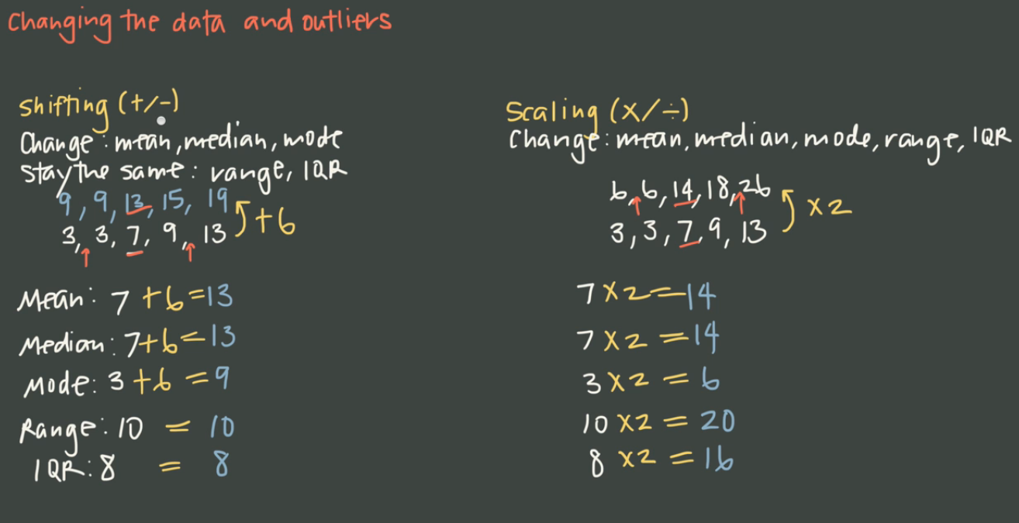

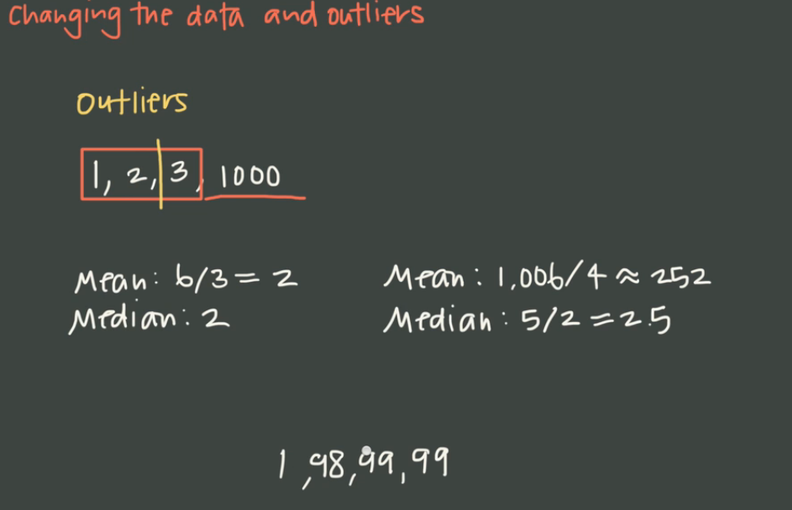

**BOX & WHISKER PLOT: (Five number summary)**

**We can get, median, largest, smallest, Q1,2,3,4, Range and IQR**

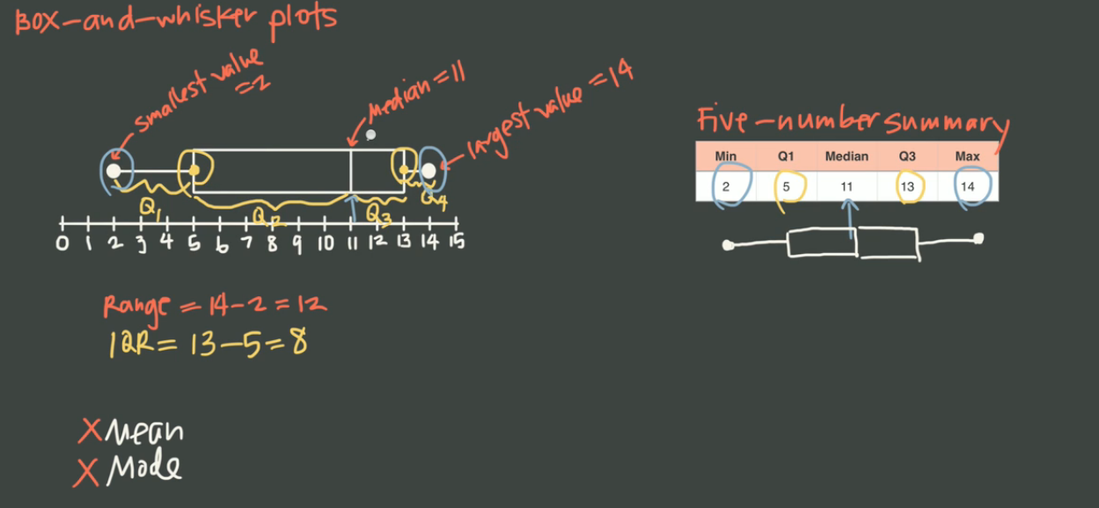

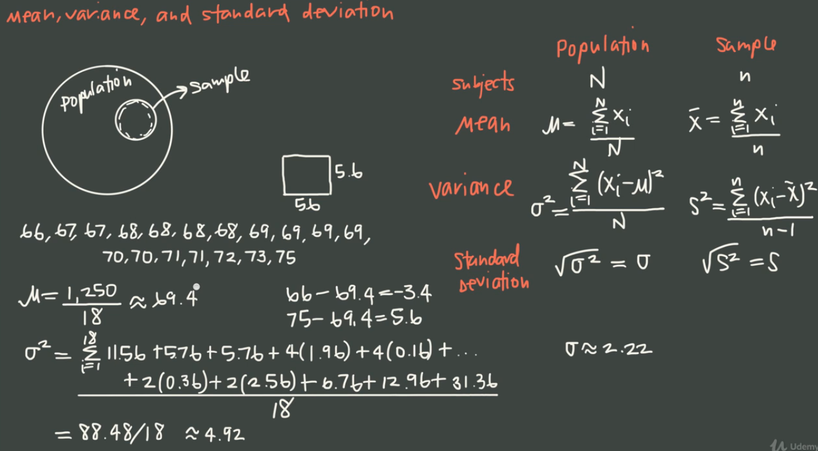

**The sample should be representative to population**

**Variance🡪** the measure of spread around the mean, the square give weightage to the outlier

Variance creates an area, since it creates a square.

**n-1🡪**  in Sample, because to correct the error ie unbiased/accurate version.

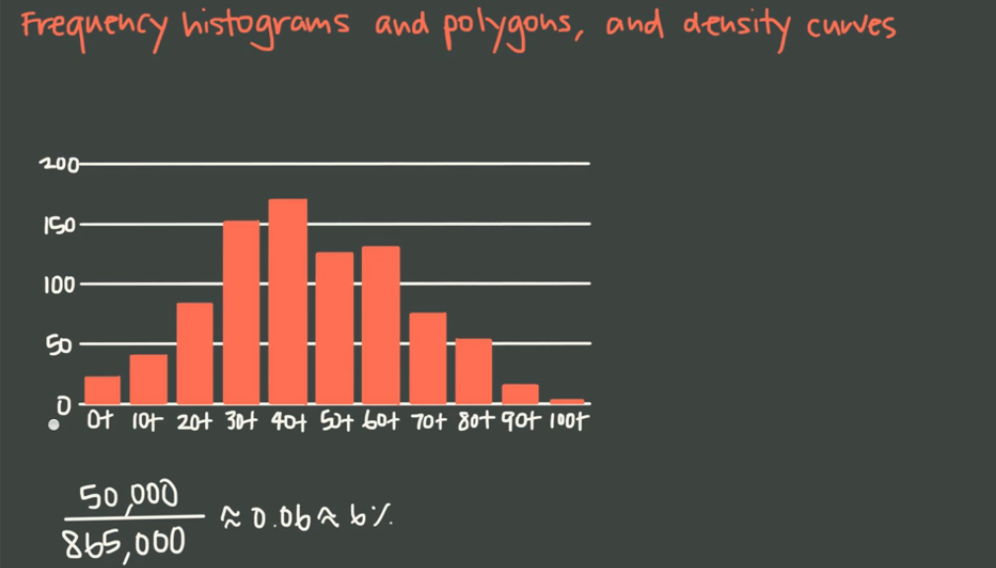

Frequency Histogram is similar to Histogram

The vertical axis is changed by finding the percentage for every bar with total value

Density Curve🡪 Smooth line, to calculate the Area under the curve.

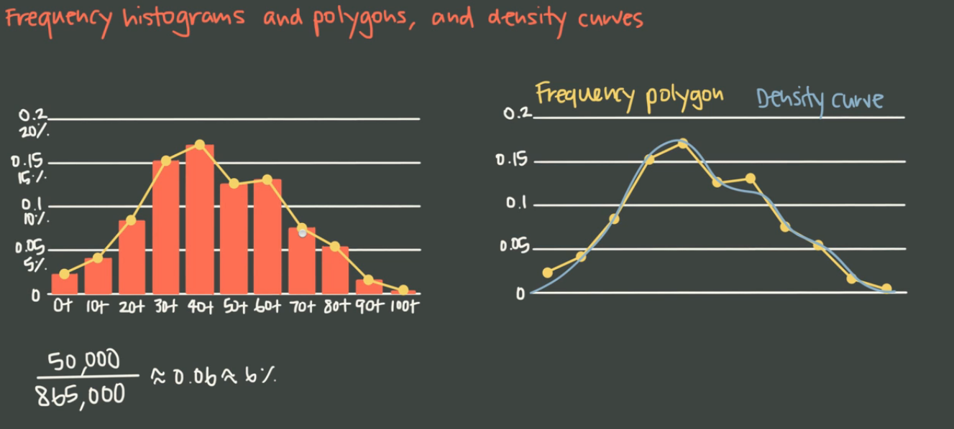

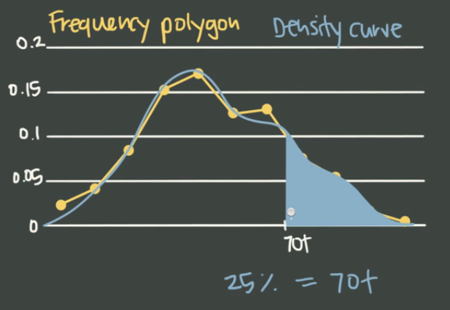

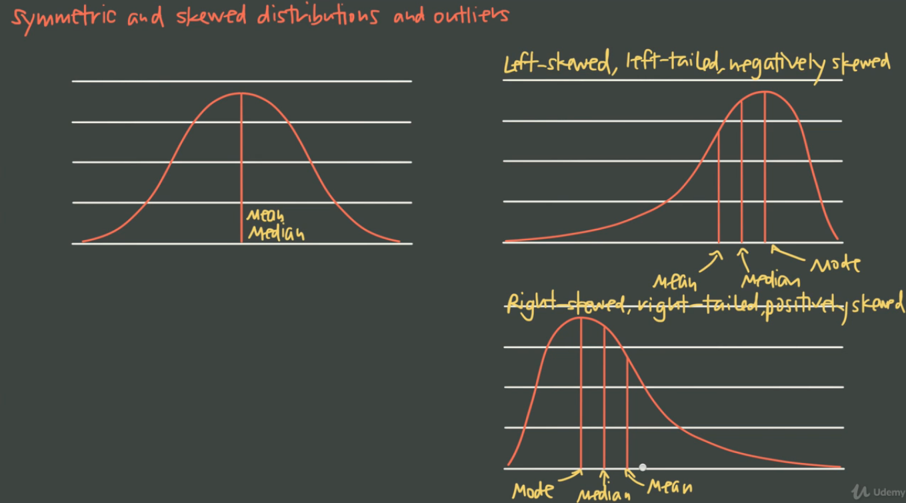

**Symmetric**🡪 Normal Distribution or bell shaped, it’s like a mirror image ie Left== Right. Mean, Median and mode is same in Symmetric

Left skewed/ Left-Tailed 🡪 see the tail position

In Skewed Symmetric, the mean, median, mode lies at different position in the distribution.

**Outliers exists at the end, pulling the distribution and the mean**

Median and IQR-🡪 **Skewed**

Mean and Standard deviation🡪 **symmetric**

How to calculate the outlier? Use IQR Value

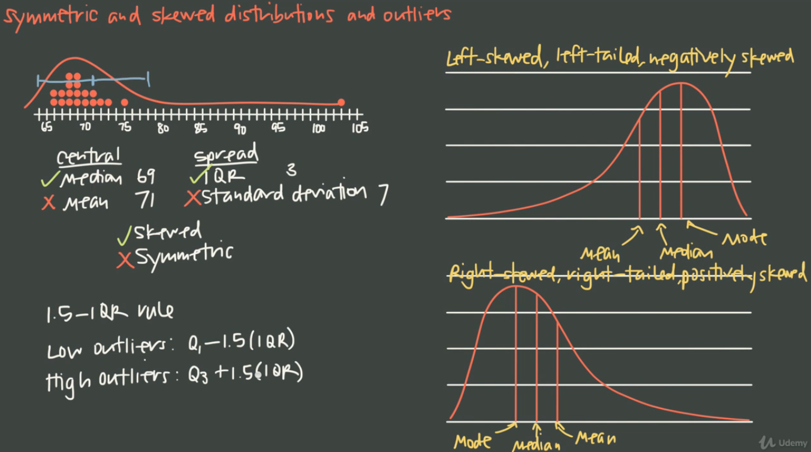

Empirical rule for normal distribution

68 %--> one Standard Deviation

95 %--> two SD and 99.7% 🡪 3 SD

Z-Score🡪 How far a point is from the mean and use the Z- table. We also have neg score.

Z-Score give the area to the **left**

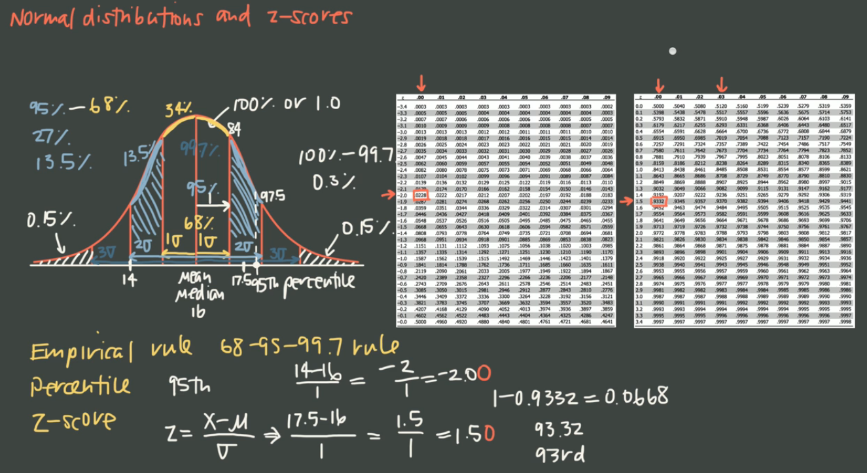

**Introduction to Probability:**

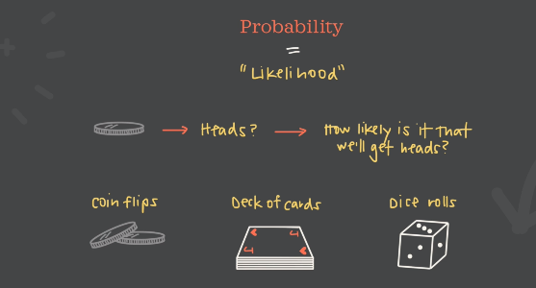

The more experiments we run , the closer our experimental probability to the theoretical probability.

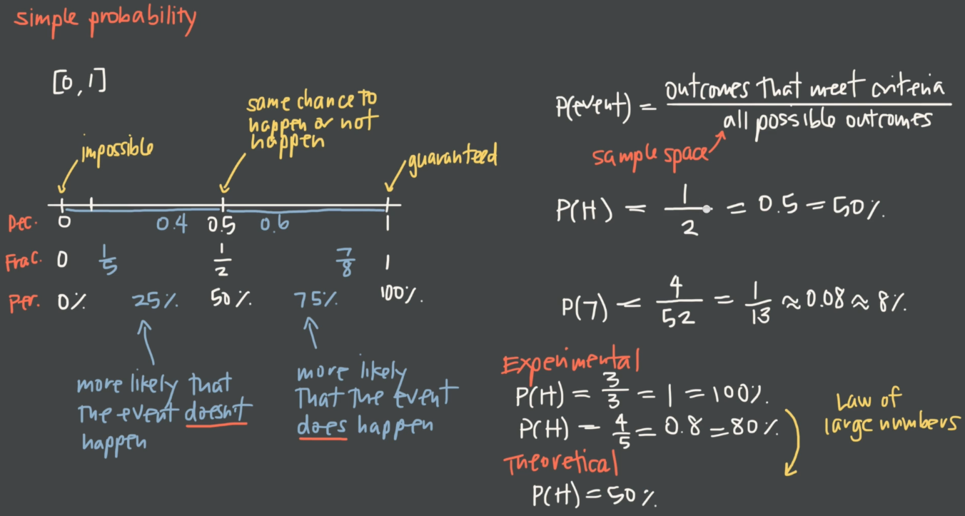

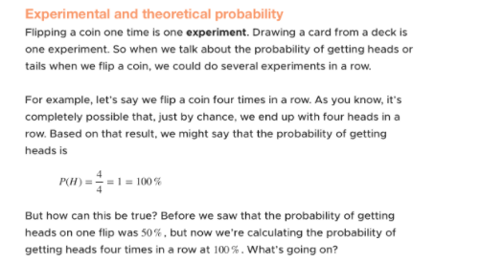

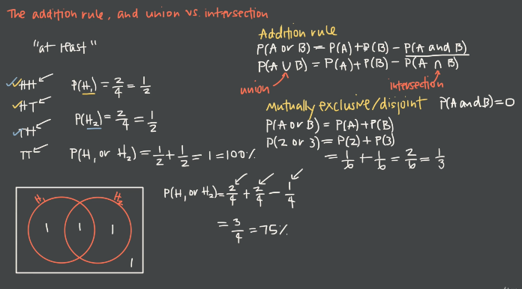

Make sure you remove the intersection(or else it will be a double count which result is wrong ans).

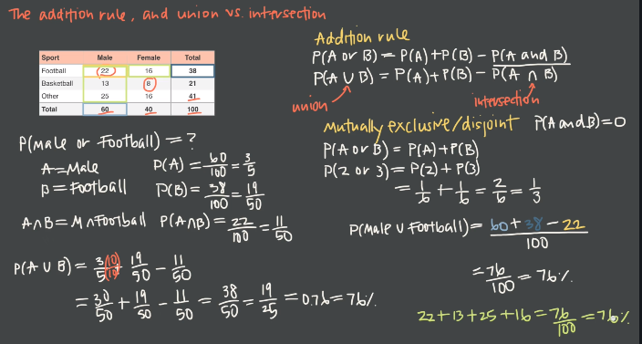

Mostly dependent events happen, when you are drawing a card from the deck (let’s say-King) and you are not replacing back in the deck. Then we will get a new universe based on the conditional probability

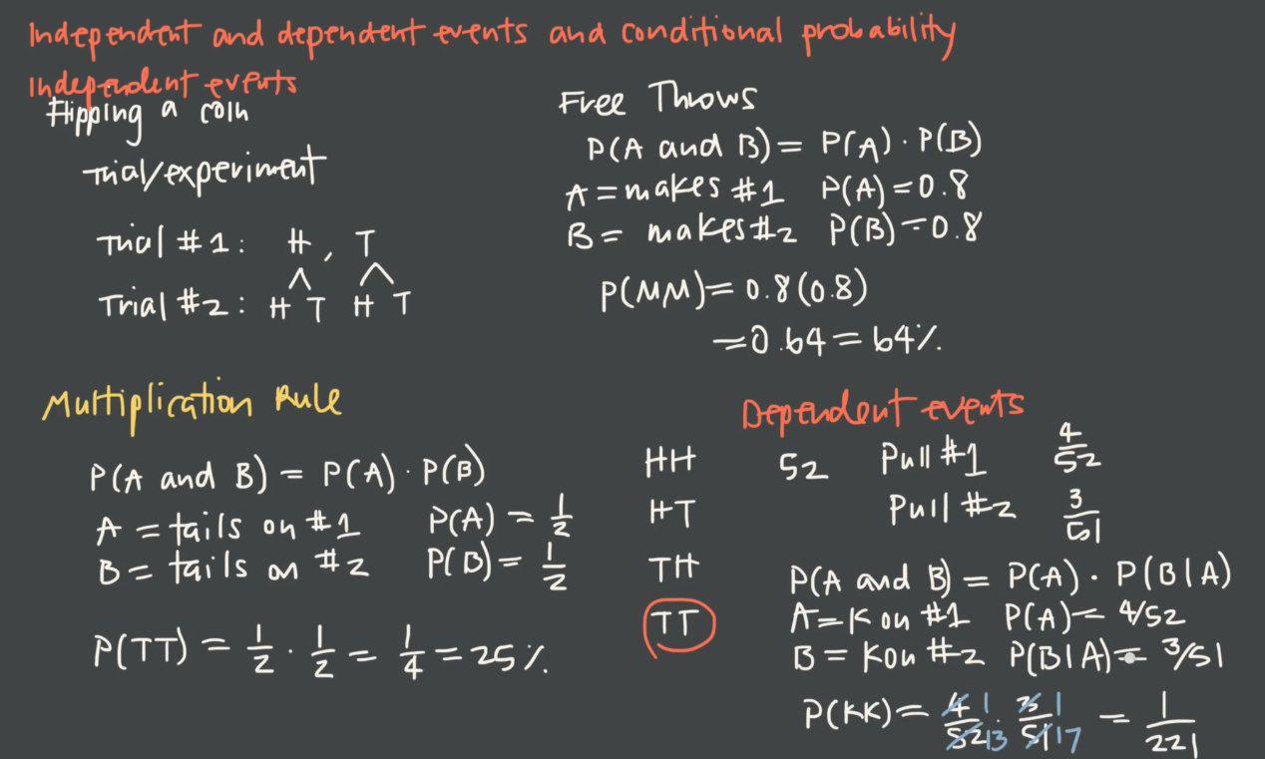

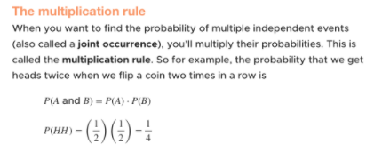

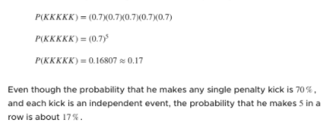

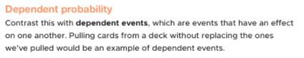

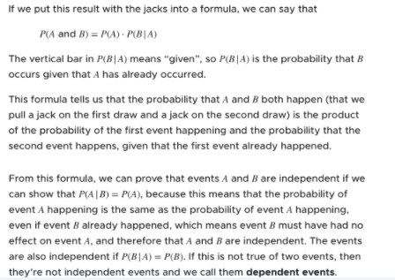

To prove an event is dep or independent, use the above formula.

**Bayes Theorem:**

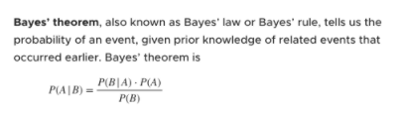

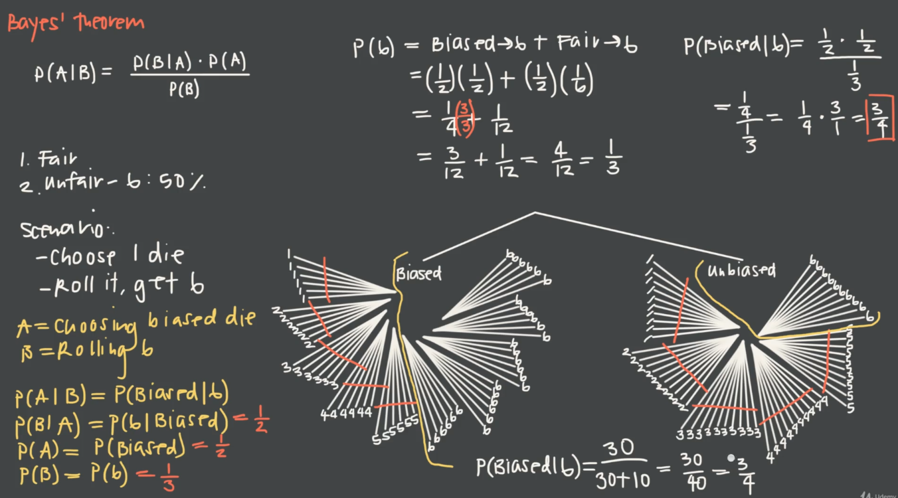

**Introduction to Discrete Random Variable:**

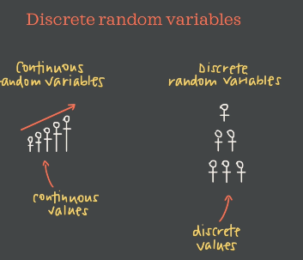

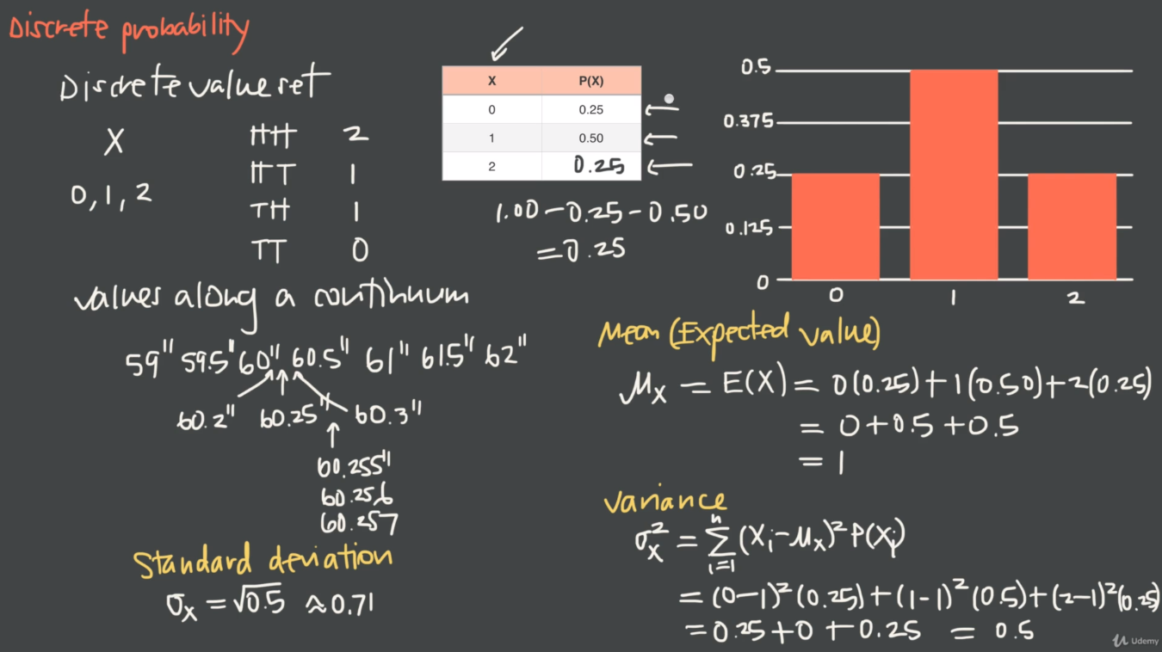

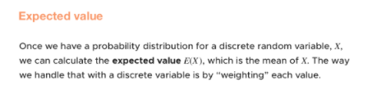

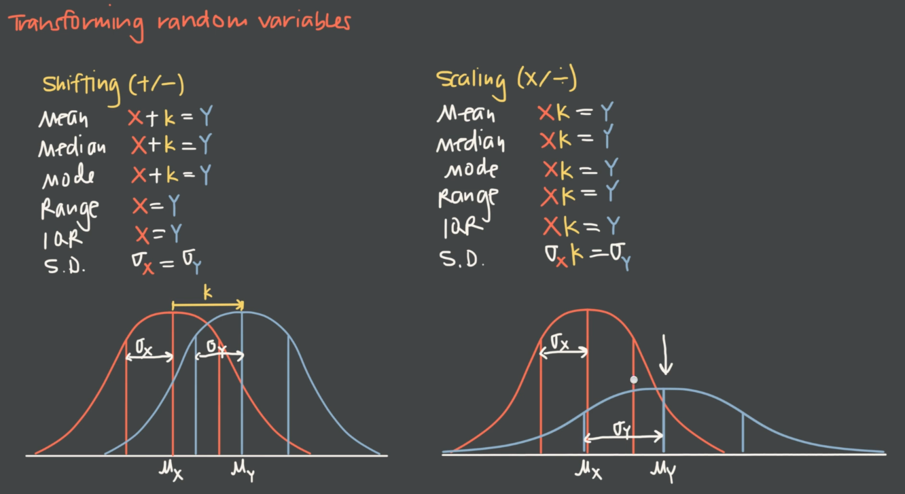

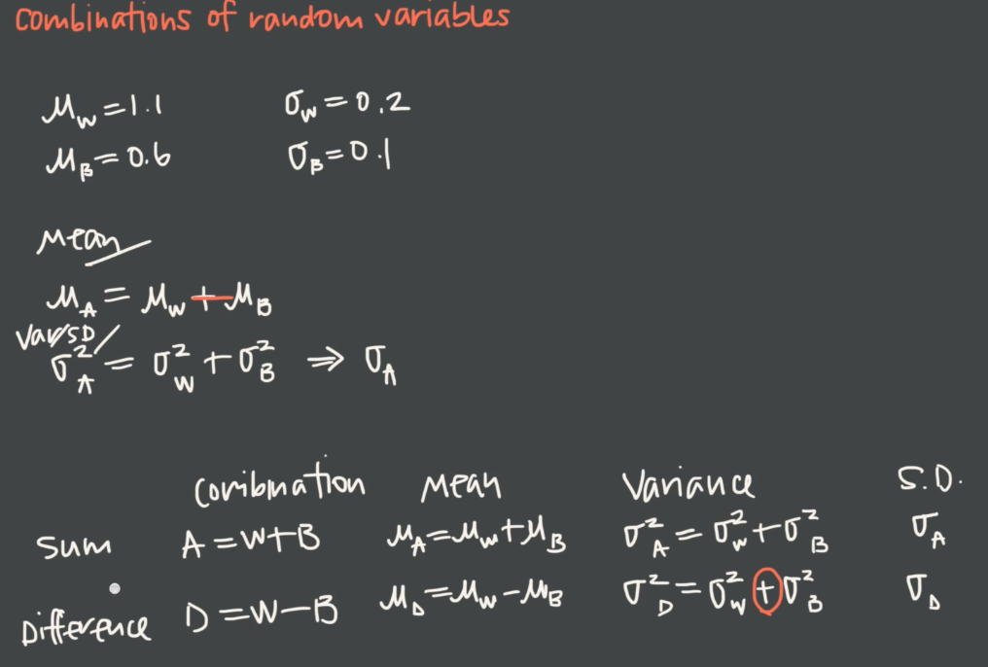

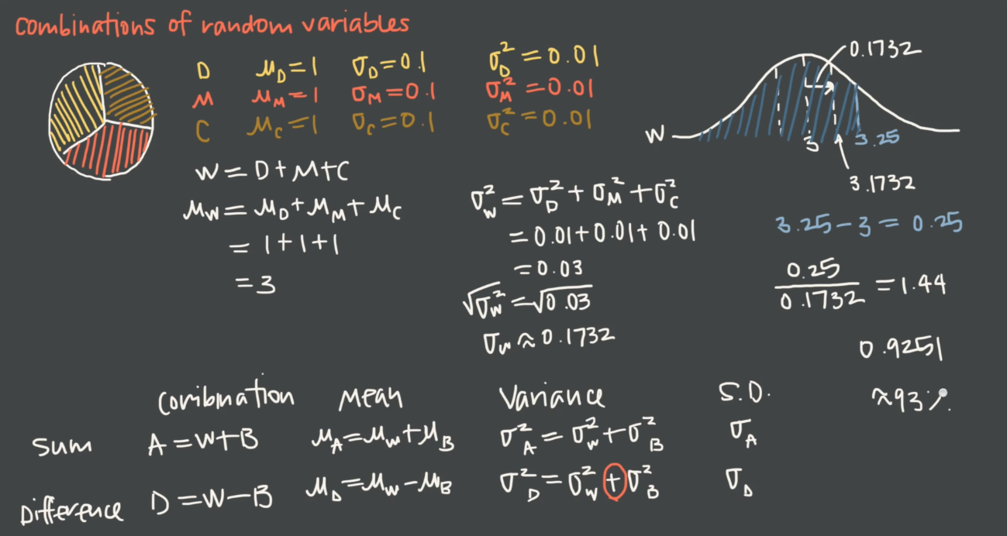

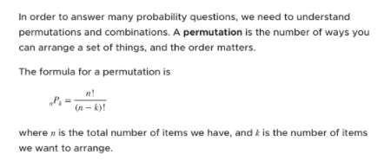

Ie. each order is considered as a possibility.

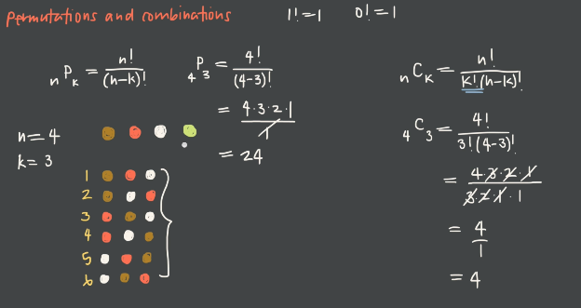

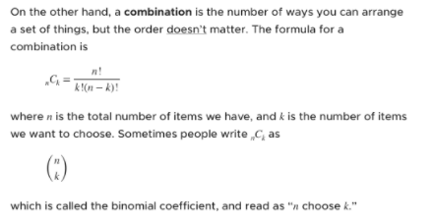

BINOMIAL DISTRIBUTION:

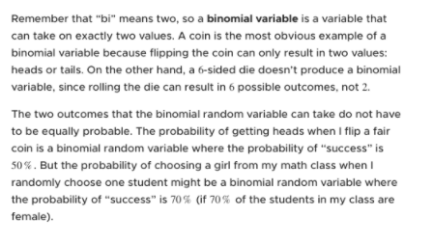

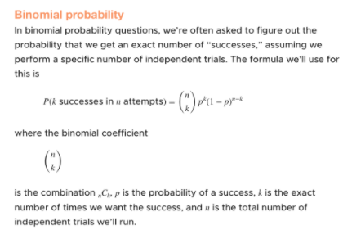

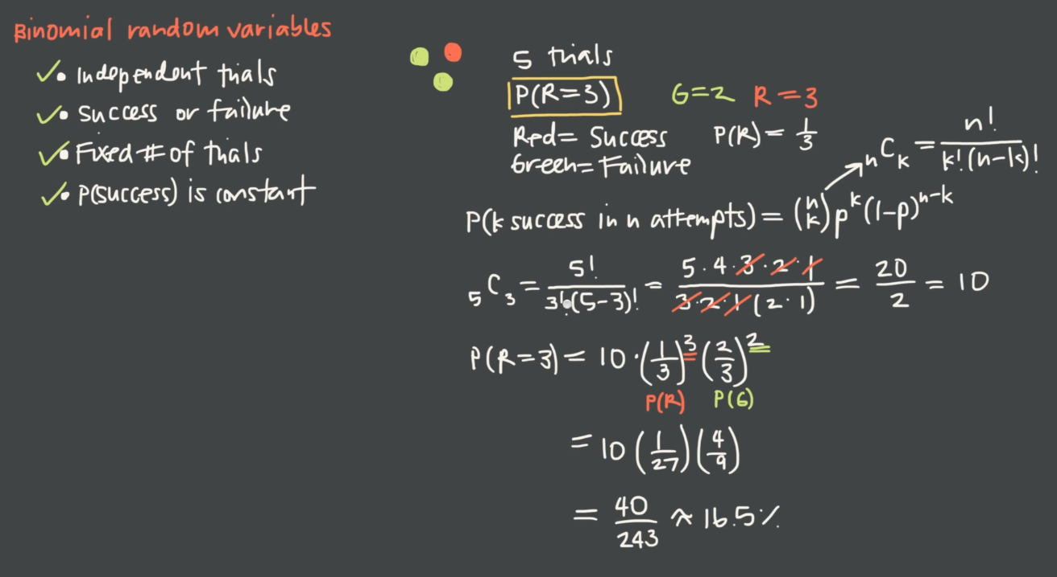

**EG:**

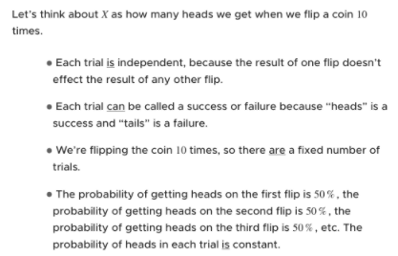

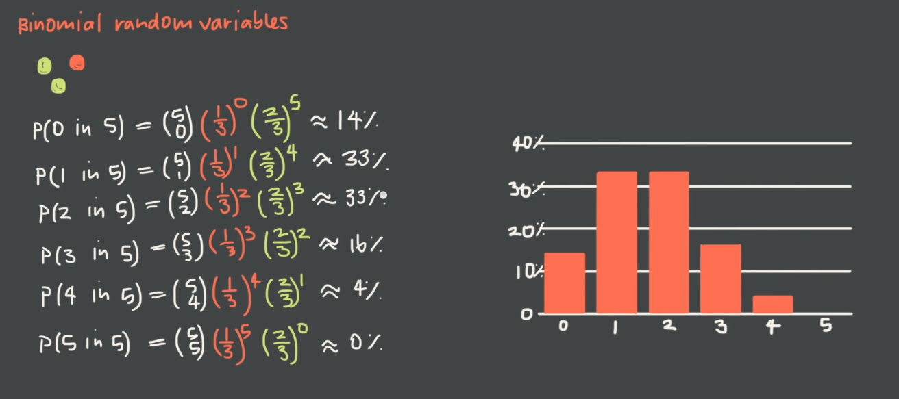

**POISSON DISTRIBUTION:**

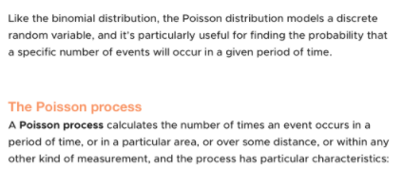

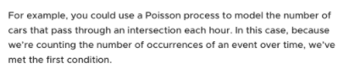

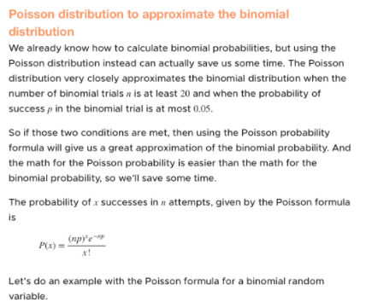

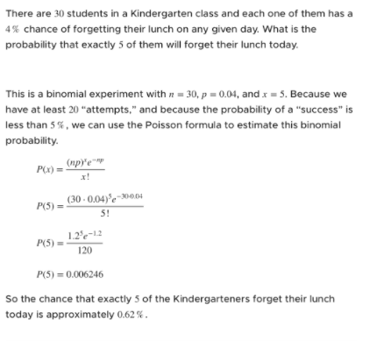

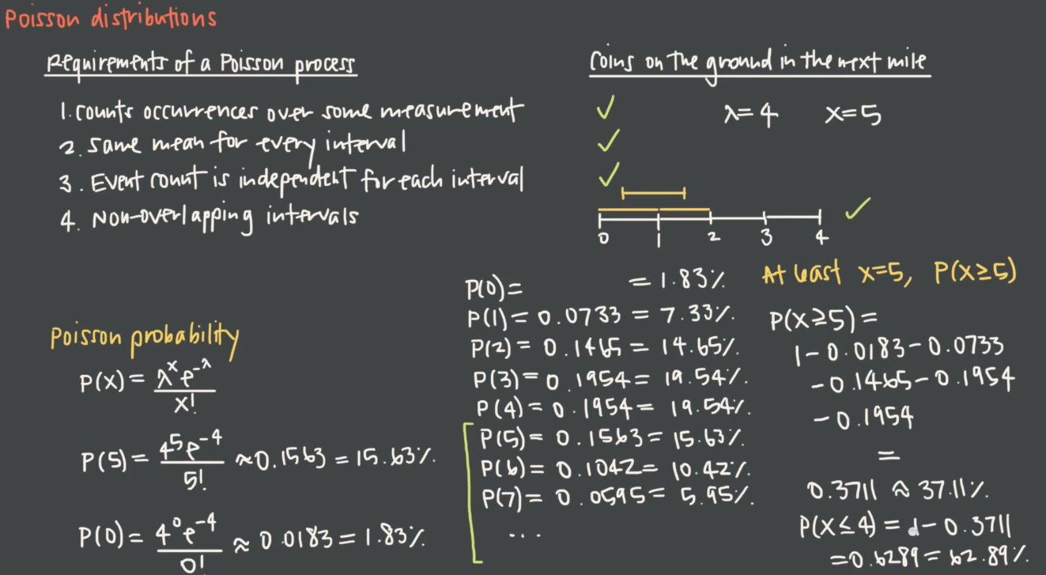

Poission Distribution for the above eg,

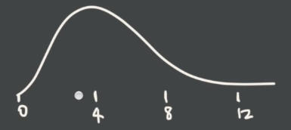



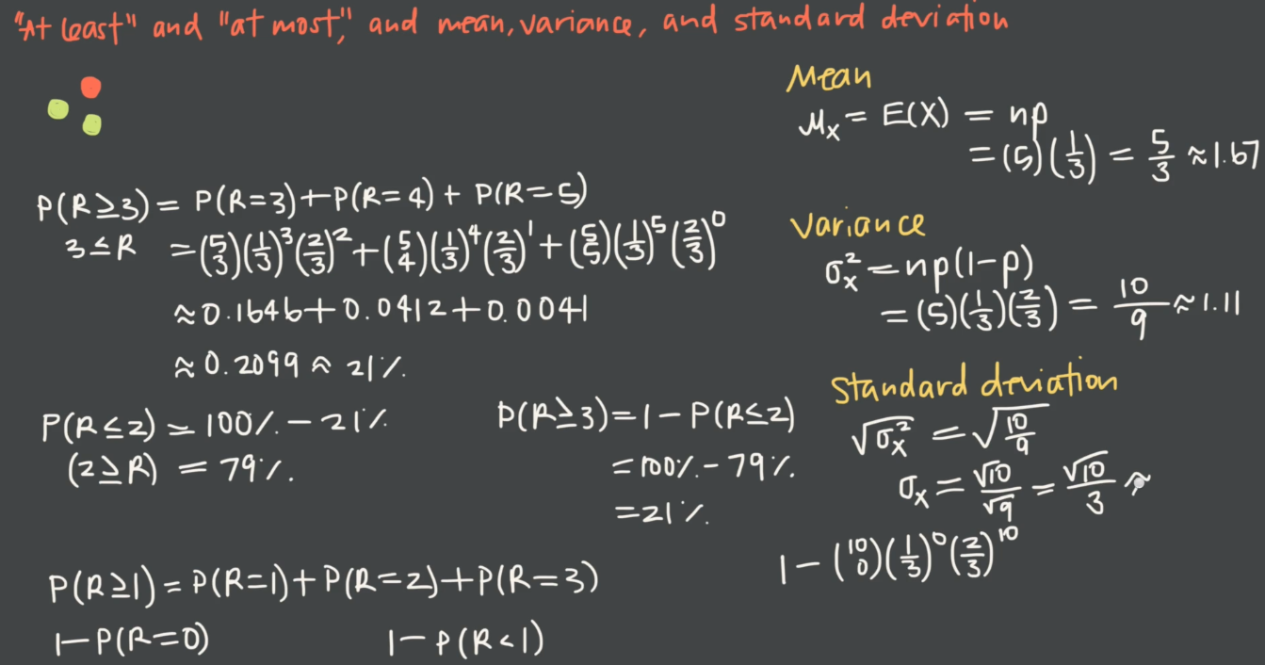



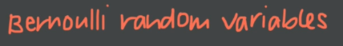

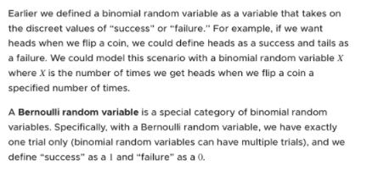

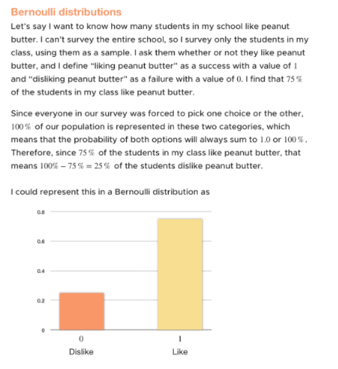

EG:

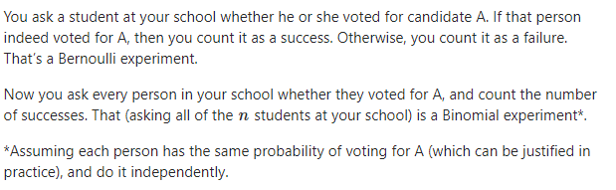

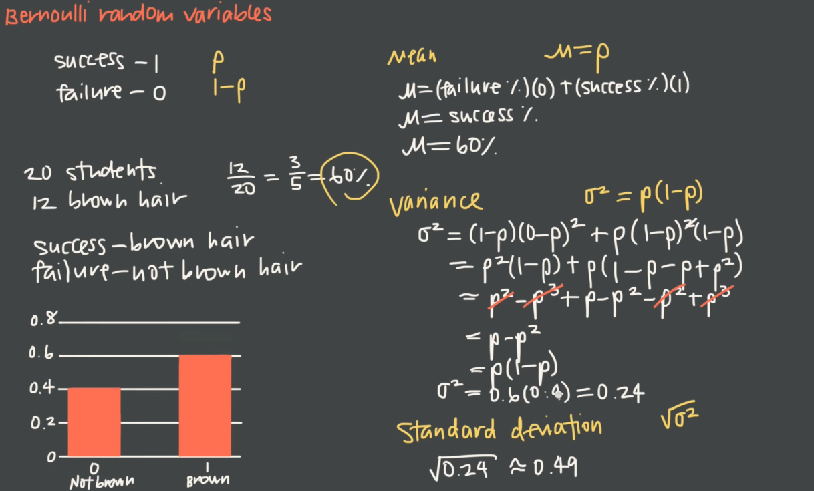



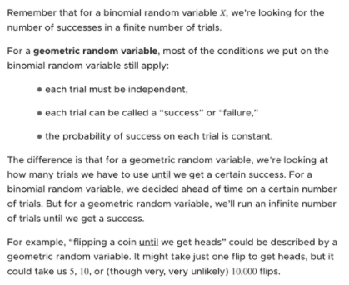

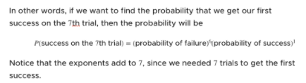

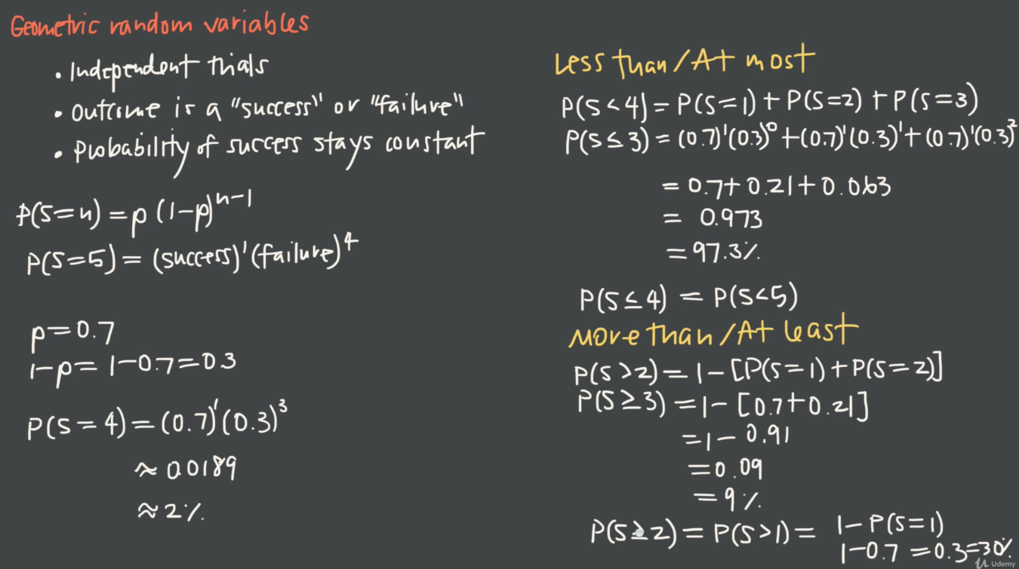

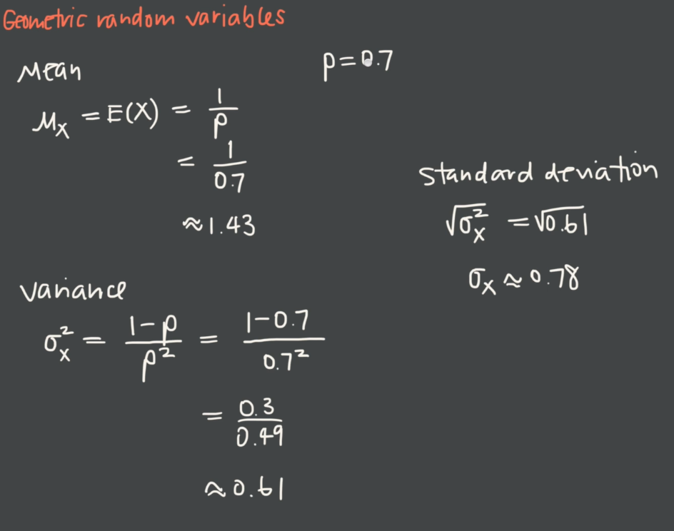

**SAMPLING:**

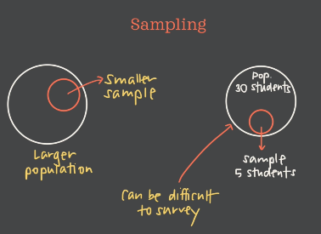

To avoid confounding, see the below content

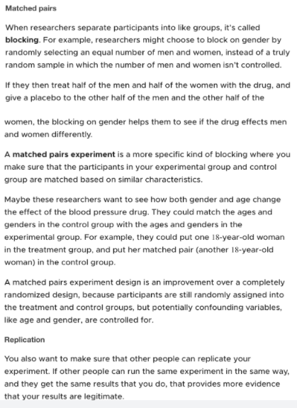

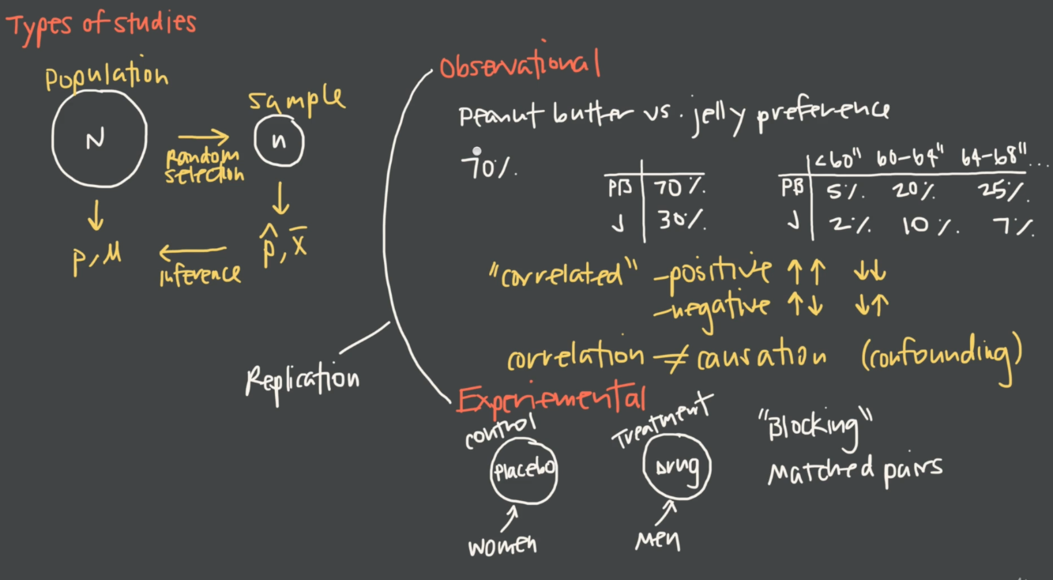

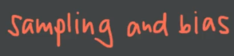

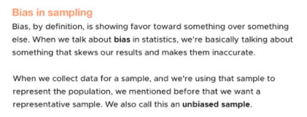

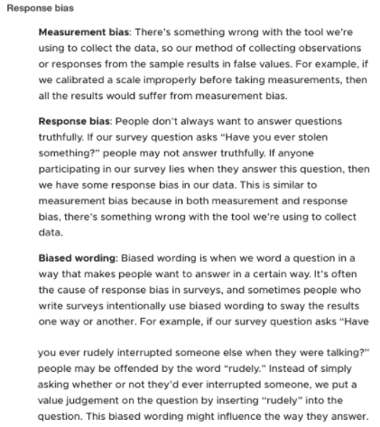

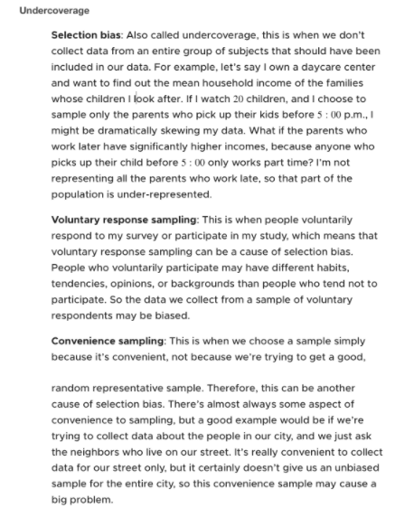

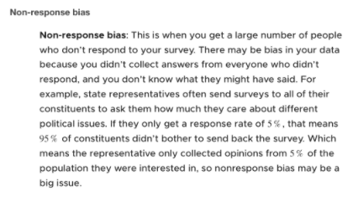

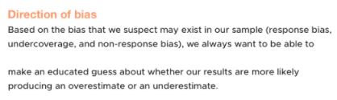

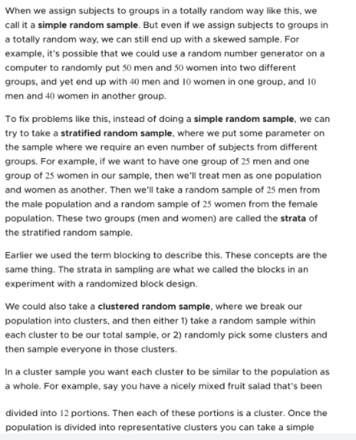

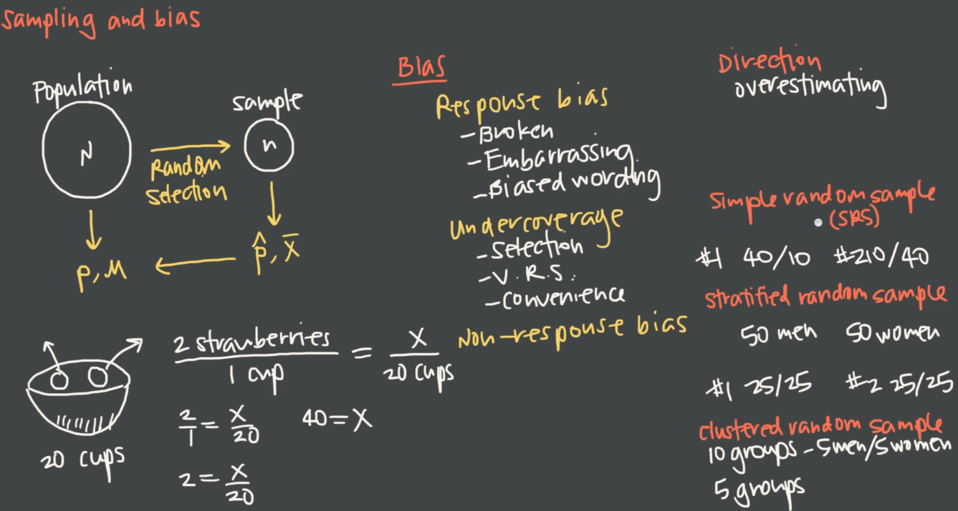

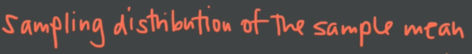

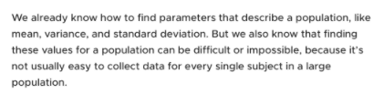

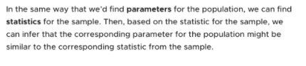

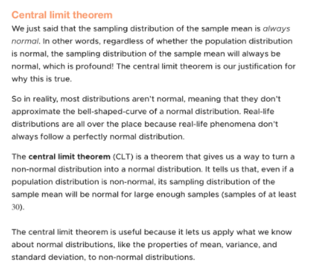

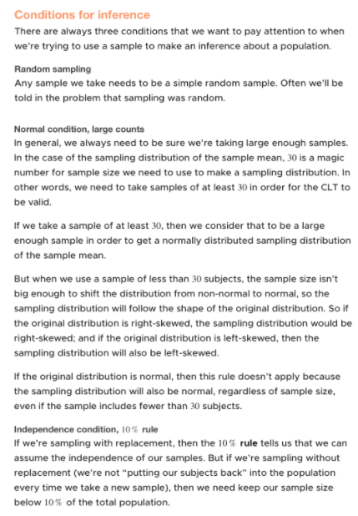

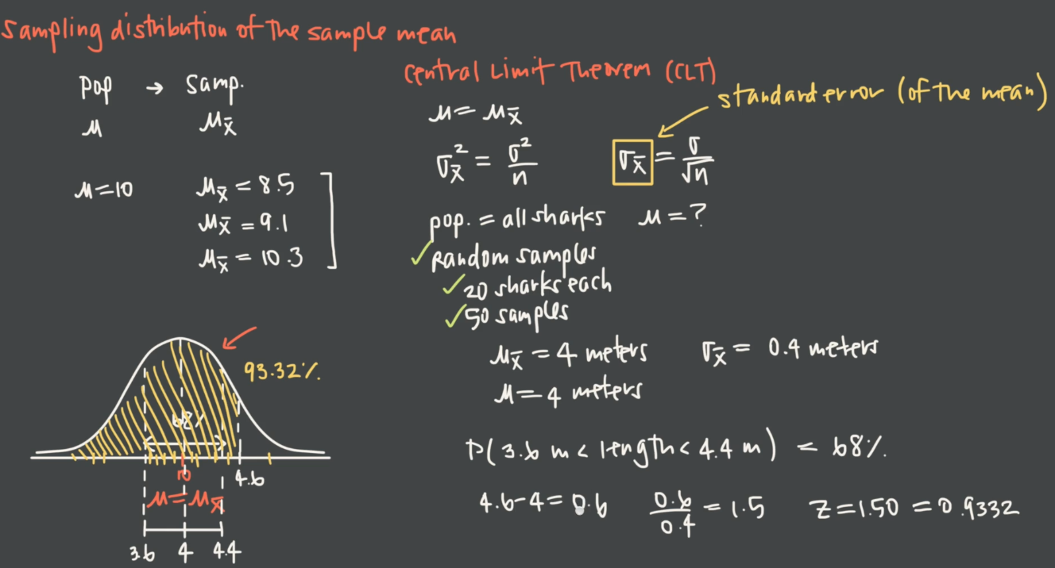



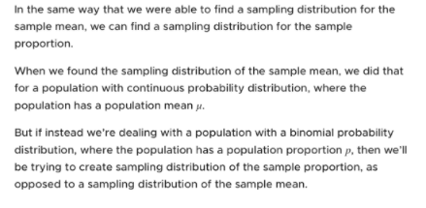

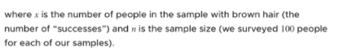

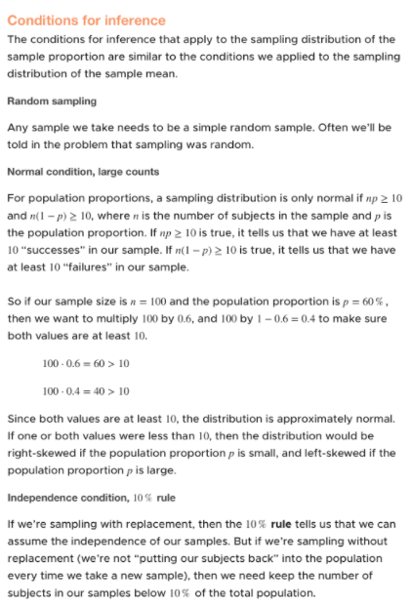

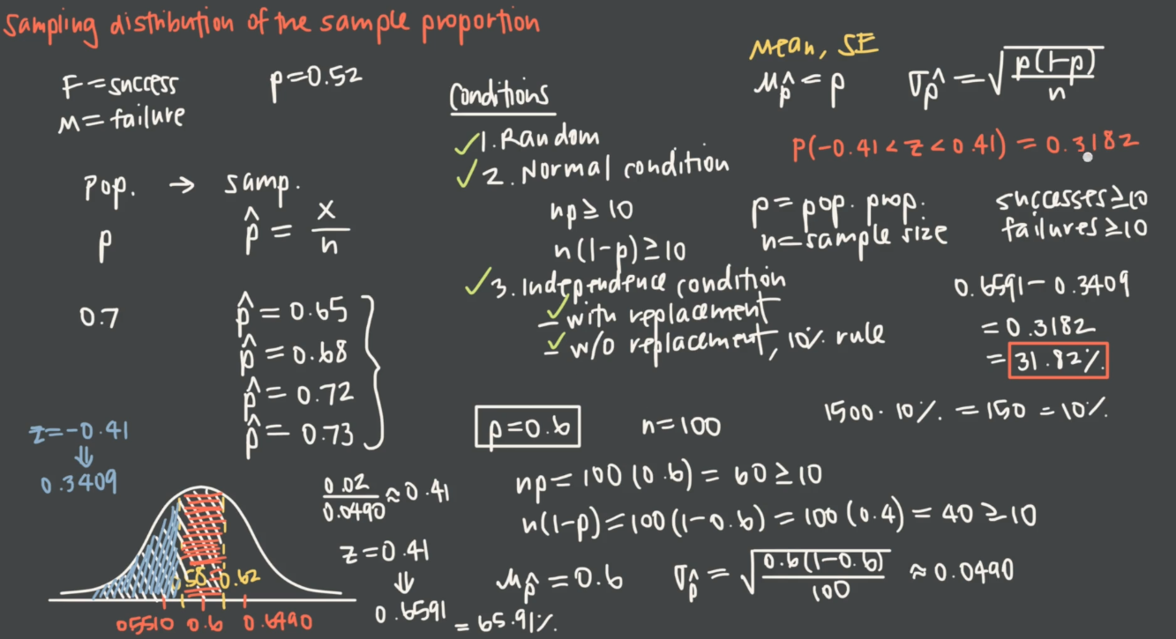

Krista

**Hypothesis Testing:**

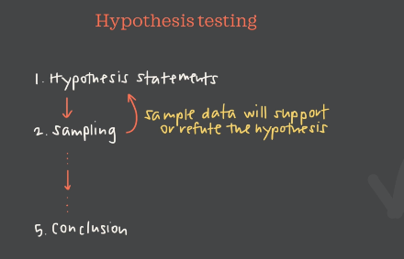

Hypothesis🡪 a tentative solution to the problem that we are going to proceed. WE come to the conclusion based on the data/information.

Order is important in hypothesis testing

**Two types:**

1. Null Hypotheses (Ha)🡪
2. Alternative Hypothesis(H0)

We can only support the hypotheses and we can never prove at the conclusion.

Null hypotheses and Alternative are complements/opposites to each other.

**EG1:** Class marks

**EG2:** class proportion

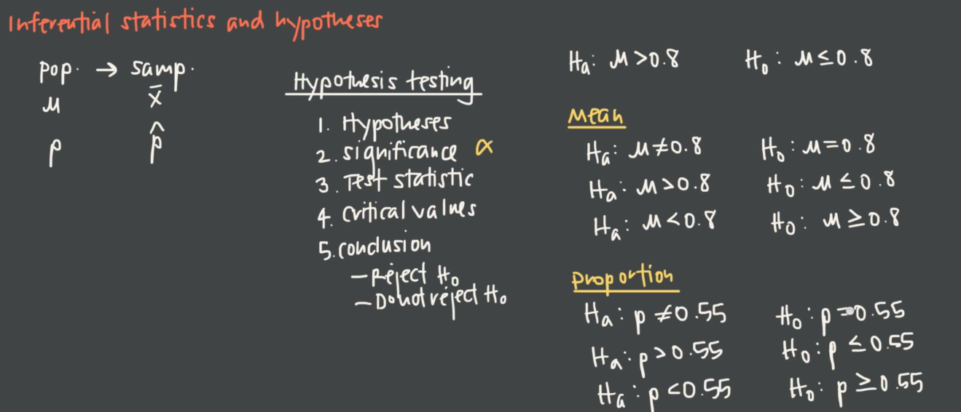

EG: Eating ice cream will cause fever🡪 null hypothesis

Dad🡪 Eating ice cream cause Fever🡪 Alternative hypothesis

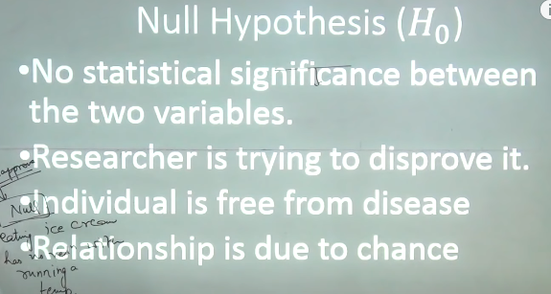

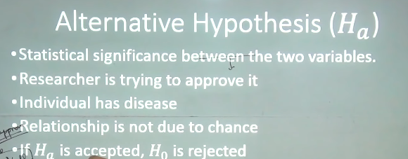

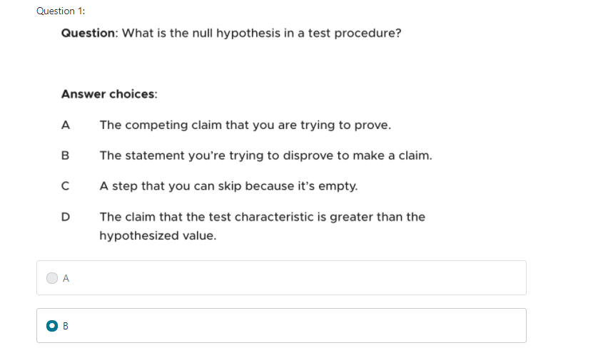

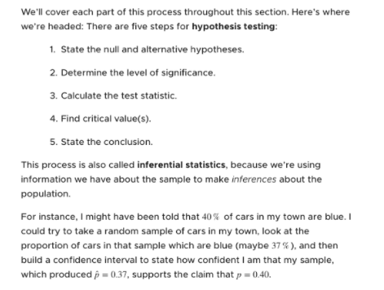

**Step 2: Significance Level**

Set the confidence level and calculate alpha.

If we are developing a drug, if there are any error people might die. Then the confidence level should be high.

It is similar to confusion matrix

Type 1 error is called alpha value

Type 2 error is called beta

There will be a trade of between the type 1 error and type 2 and the size of data.



